#### 

Athlone Institute of Technology

Athlone

**REPORT**

**WEBSITE NAME**: IRELAND WEATHER FORECAST

**SUBJECT:** CLIENT-SIDE TECHNOLOGIES

**MADE BY**

Abhik Rai

A00258752

**INTRODUCTION**

Ireland Weather Forecast displays the weather for some of the cities in Ireland.

**The main features of this website are listed below:**

1. **Listing cities**:

List of some of the cities in json format is taken from openweathermap to load from drop box.

1. **Displaying weather data**:

Characteristics of weather will be displayed in card layout for best user interface

1. **Displaying Graphs**:

Data is parsed from XML and it will be used to make graphs. It shows the statistical analysis in the form of line and bar graph.

**SCOPE OF WORK**

**Objective:**

The main objective of the project:

* To provide weather predictions for the city selected from the drop down box.
* To display information using cards and graphs

**Technologies Used:**

* HTML
* CSS
* Bootstrap
* JavaScript
* AJAX
* XML

**Libraries Used:**

* Charts.js – For using charts.

**SCREENSHOTS**

**\*WORKS BEST WITH MICROSOFT EDGE\***

* **Selecting city:**



* **Drop down for city list: (For now I have only added 5 cities)**

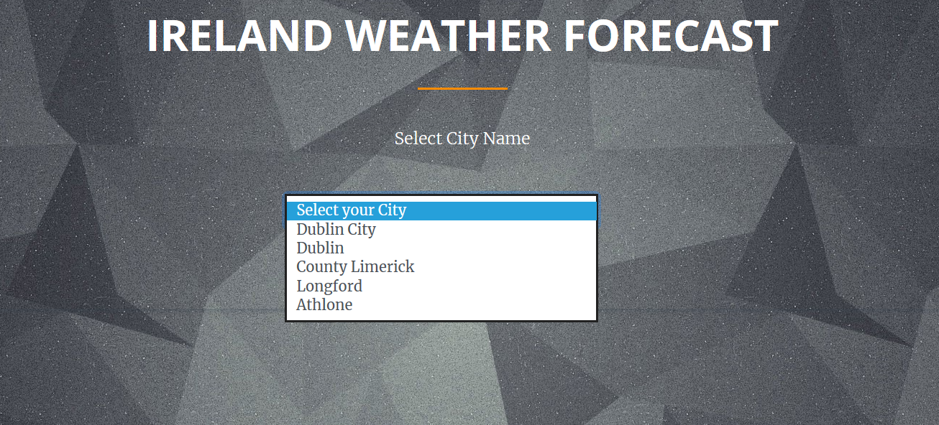

* **Weather cards for selected city from drop down:**

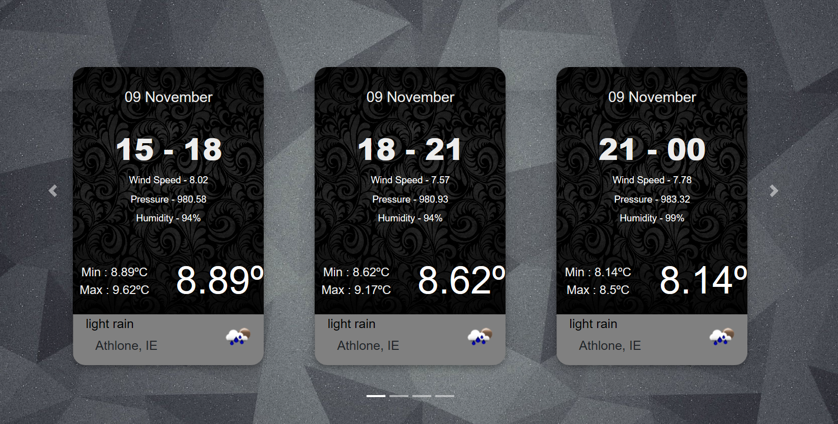

* **Statistical analysis using line-graph, the temperature can be seen using the hover effect**

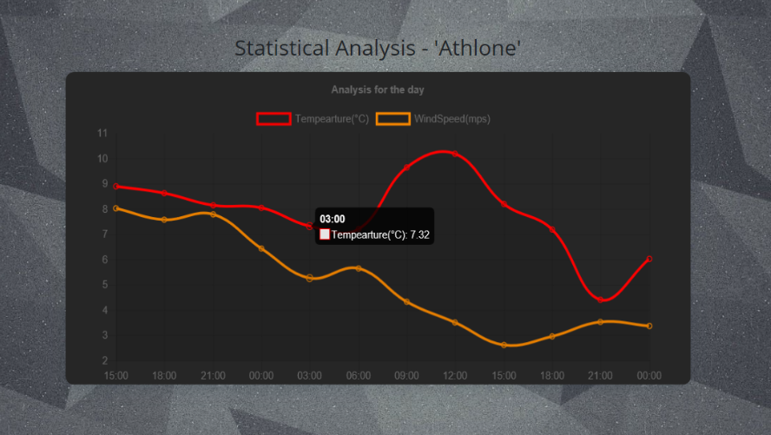

* **The bar-graph for showing precipitation level for a day**

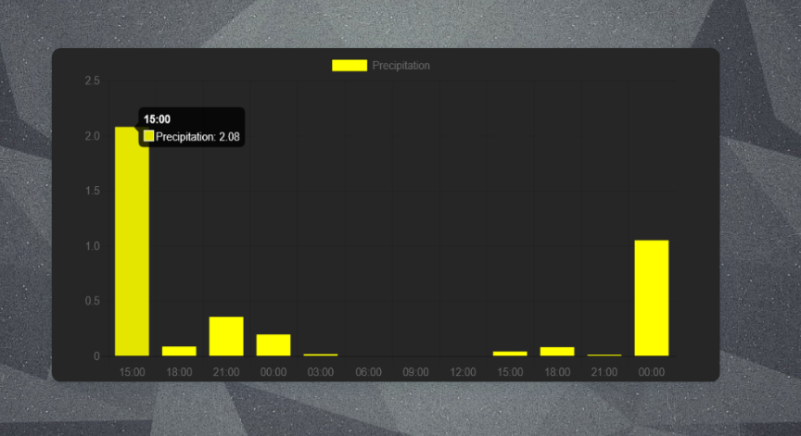

**IMPLEMENTATION & FUNCTIONALITIES**

* **Getting City List:**
* Openweathermap provides list of cities along with the city-ID and country in a json file named as city_list.

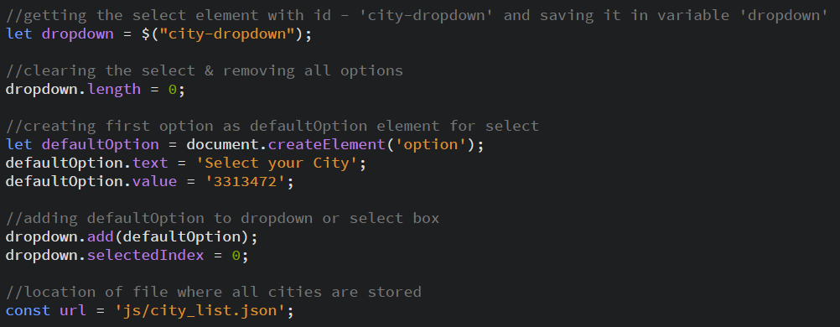

* Make AJAX request to the JSON file which contains the list of cities.

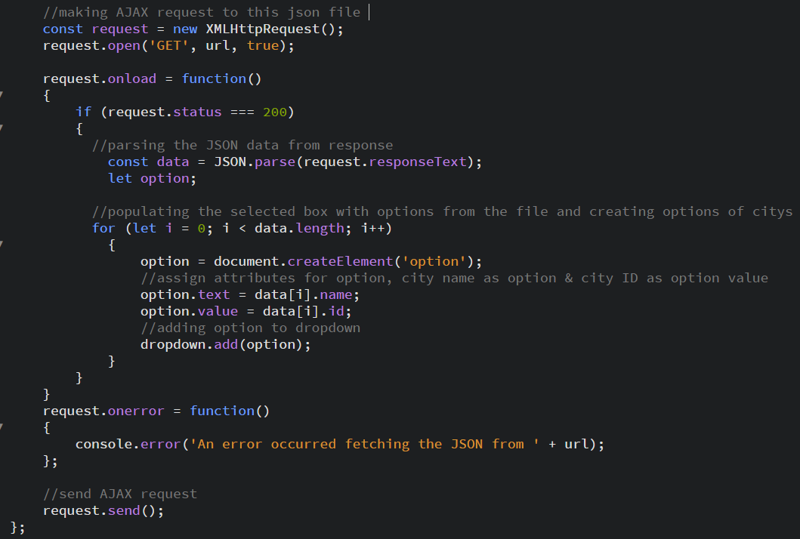

* **Getting weather data & Creating elements accordingly**
* Using City ID to get the weather forecasts for 36 hours

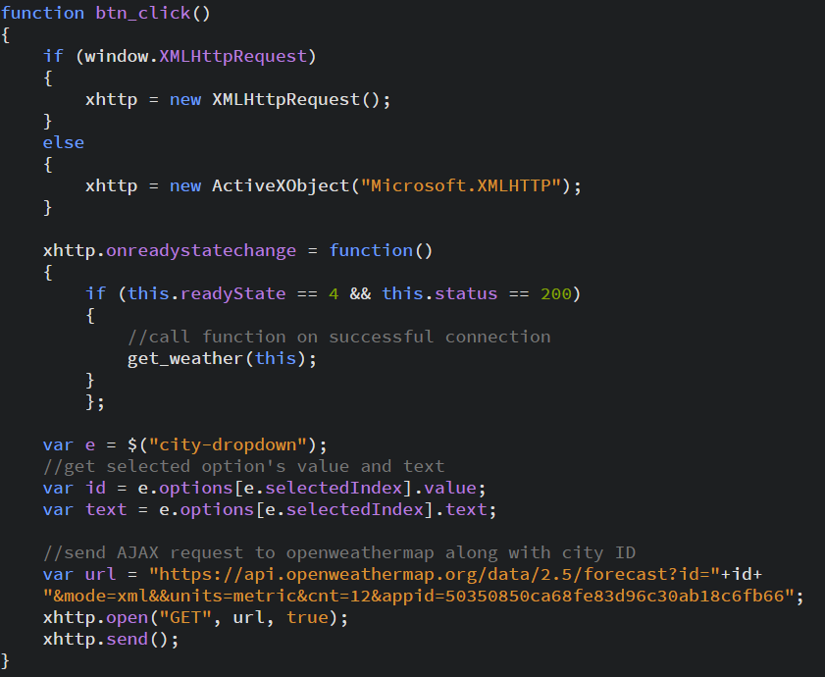

* Extracting the XML data which we got from AJAX request.
* Creating document elements and populate it with weather data.
* Getting all the forecasts with time tag and extract all the weather details.
* Getting the image from openweathermap based on climate.
* Creating carousel for cards

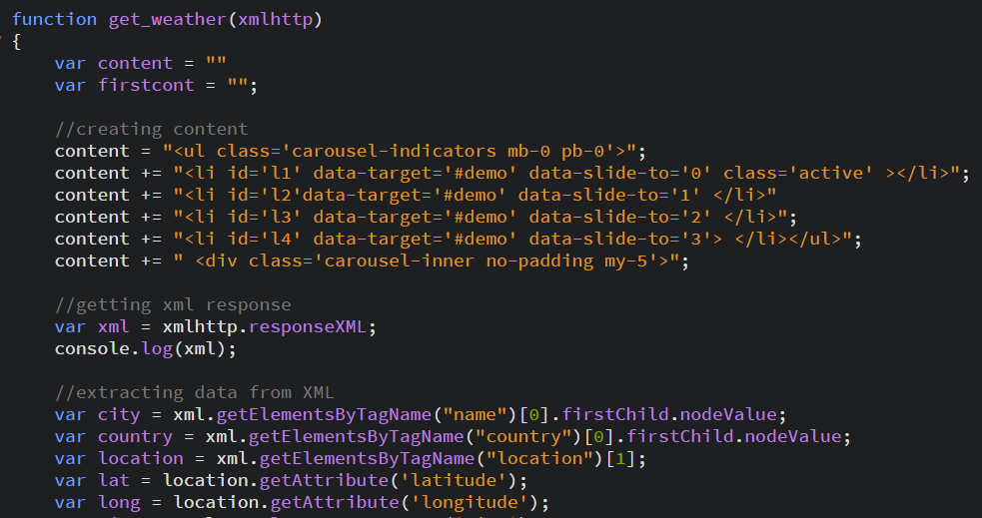

* Extracting time forecast and creating weather-cards.

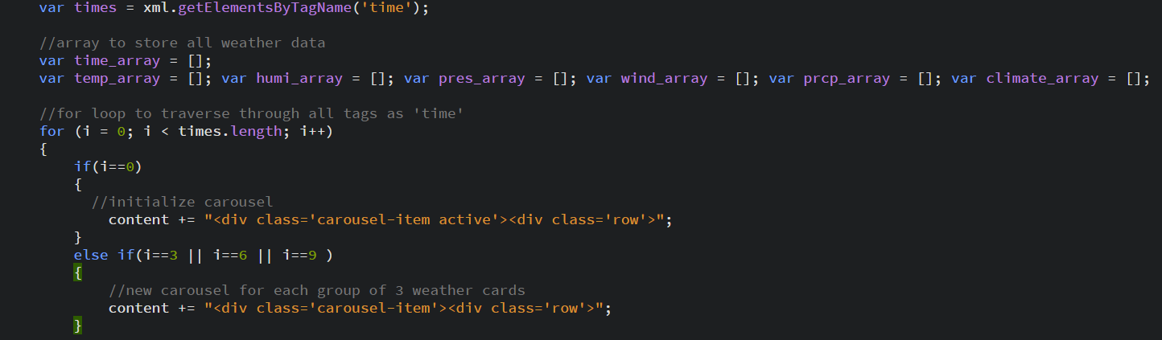

* Extracting attributes for every forecast

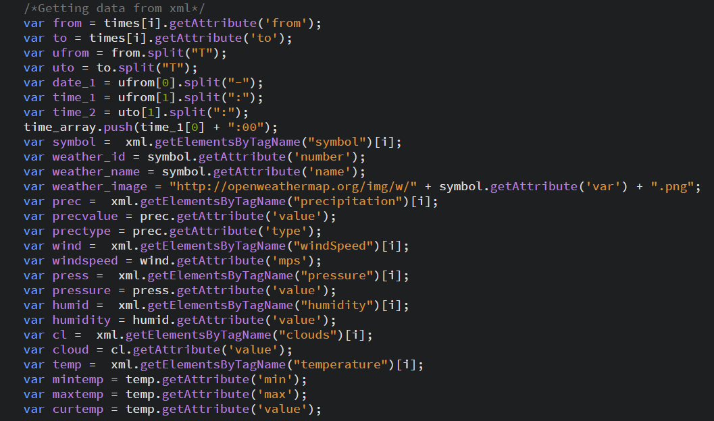

* Creating Weather card for each weather code.

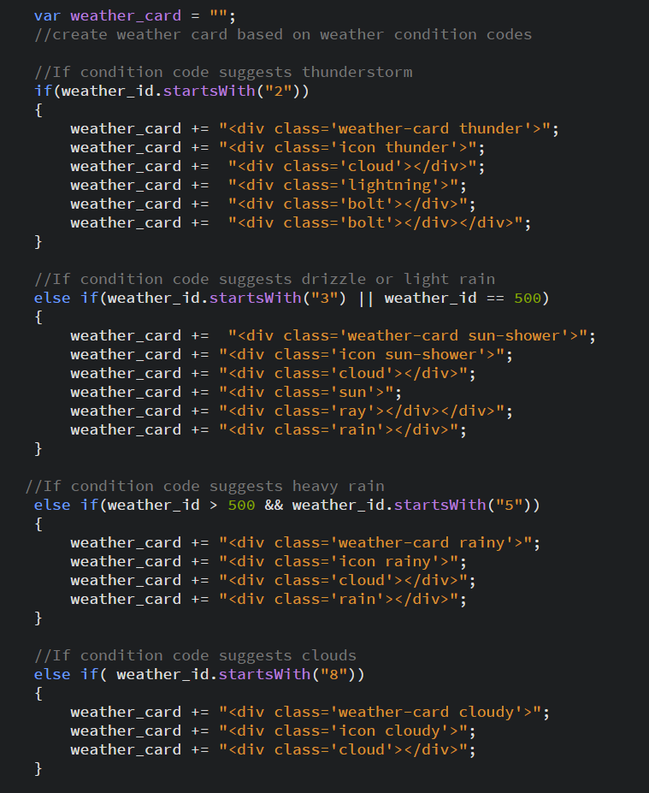

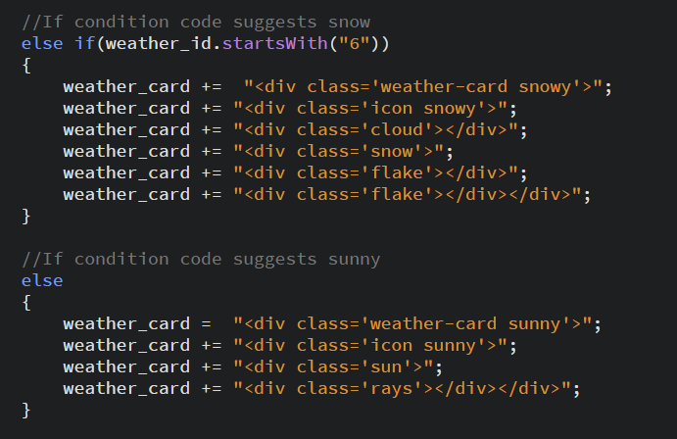

* Filling weather card with weather data

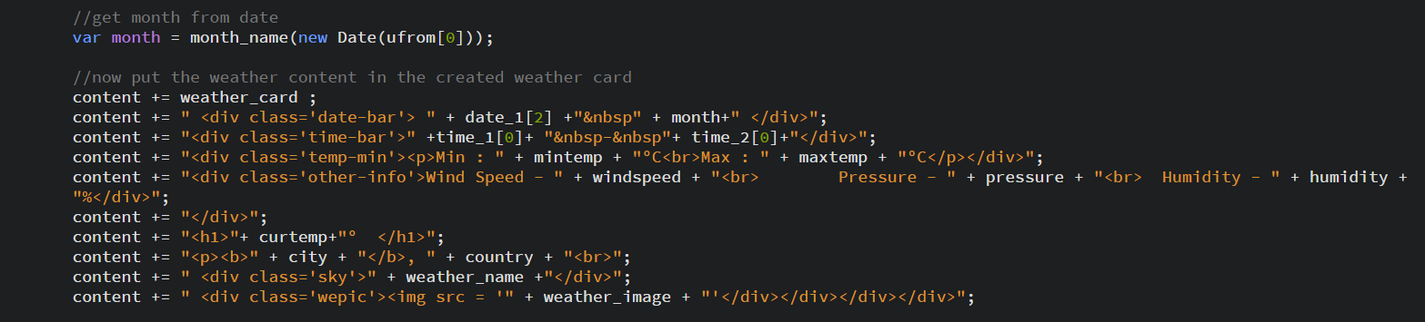

* Closing carousel & using innerHTML to create all the elements

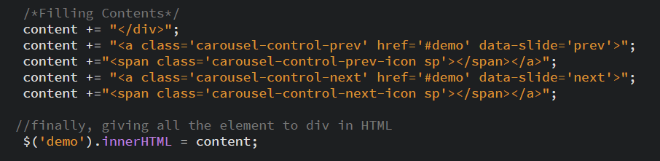

* **Creating graph for Visualisation**
* Line graph to display variations in temperature and windspeed
* Bar graph to display precipitation

**Implementation:**

* Make chart div visible & add title for chart.
* Clear previous canvas charts and add new canvas for new charts.

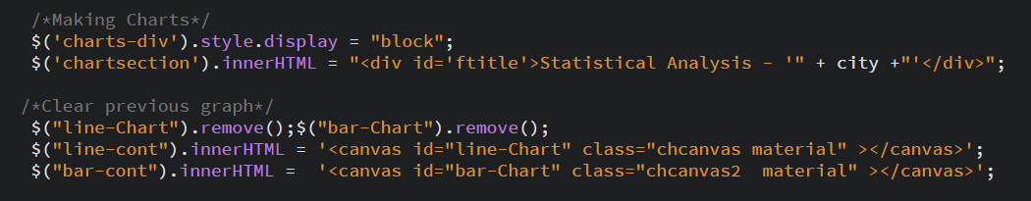

* Line Graph.

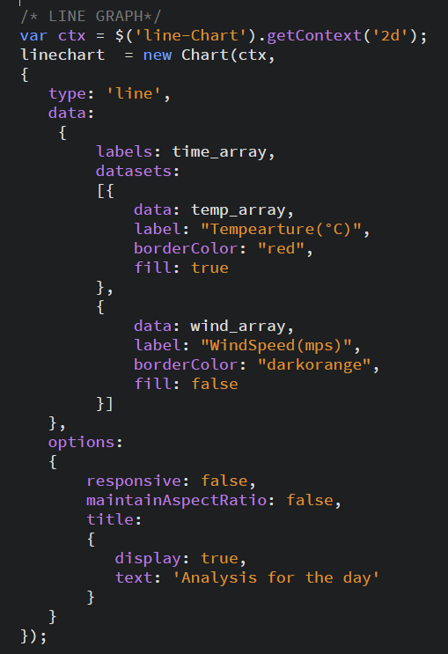

* Bar Graph

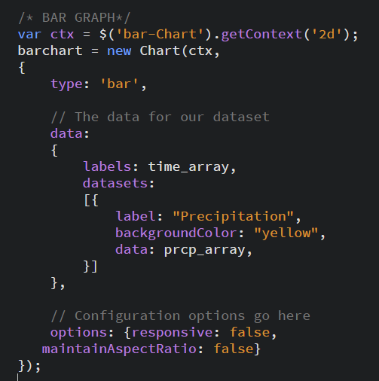

**LEARNINGS**

* XML parsing from API
* Creating cards
* Using chart.js plugins
* Creating graphs
* Using bootstrap